

|  |  |  |  |
| --- | --- | --- | --- |
| Course Code | : | SOF104 | |
| Course Name | : | Principles of Information Systems | |
| Lecturer | : | Dr Ili Farhana Md Mahtar | |
| Academic Session | : | 2020/09 | |
| Assessment Title | : | Information System Studies | |
| Submission Due Date | : | 24th December 2020, 5PM | |
| Prepared by |  |  | |
| : | Student ID | Student Name |
|  | SWE2009509 | Meiru Lin |
|  | SWE2009500 | Xinao Hu |
|  | SWE2009510 | Aofan Liu |
|  | SWE2009492 | Mo Chen |
|  | SWE2009517 | Haiyi Wang |
|  |  | DMT2009168 | Zian Huang |
| Date Received | : | 15/12/2020 | |
|  |  |  | |
| Feedback from Lecturer:  Mark: | | | |

**Own Work Declaration**

I/We hereby understand my/our work would be checked for plagiarism or other misconduct, and the softcopy would be saved for future comparison(s).

I/We hereby confirm that all the references or sources of citations have been correctly listed or presented and I/we clearly understand the serious consequence caused by any intentional or unintentional misconduct.

This work is not made on any work of other students (past or present), and it has not been submitted to any other courses or institutions before.

Signature:

Date:

**Abstract**

After a semester of study, we have mastered a series of basic principles of information systems. We should practice what we learned in group work. As one of the largest booking systems in the world, it is undeniable that booking.com is an excellent material for us to study, which will help us better understand what we have learned.

**Keyword:** Computer fundamental; Information system; Principles of IS; Booking.com; Booking system

**Table of Content**

Introduction4

Usage of information system and its value4~7

Business process flow diagram7~9

Feature and functions10~12

Information and technology used in the system12~14

Security and ethical issues14~16

Conclusion17

References18

Marking rubrics19

**Introduction**

The booking information system is one of the most popular systems for people to arrange their vacations. It provides a series of services such as reservations, making arrangements for flights, taxis, hotel rooms, and so on. Moreover, in order to reach modern scale, it has worked for a long time (Mr.Jian, 2020) .

In 1977, Pirceline.com was built in America, and in the following years, it continuously purchased some companies that providing booking services (Booking_Holdings, 2020). Finally, the booking information system was built to combine all of them. Nowadays, different apartments work for different areas to achieve the goal of globalization. ,And there are over 28 million listings and more than 1.5 million accommodations are booked per night in this system. Besides, the booking information system works as a group information system to combine different kinds of messages to their target audiences and provide more chances for their communications.

In that way, tourists can work out a series of chain problems in travel just by browsing the website. Meanwhile, the booking information system collects raw data from different partners and processes them into useful information for travel addicts. It not only tries its best to bring a relatively cheap price to customers but also creates a platform that acts as a middle-man to connect customers to customers and makes a profit for both sides. These are why it has gained more and more popularity among the booking companies.

**Usage of information system and its value**

The business process of Booking

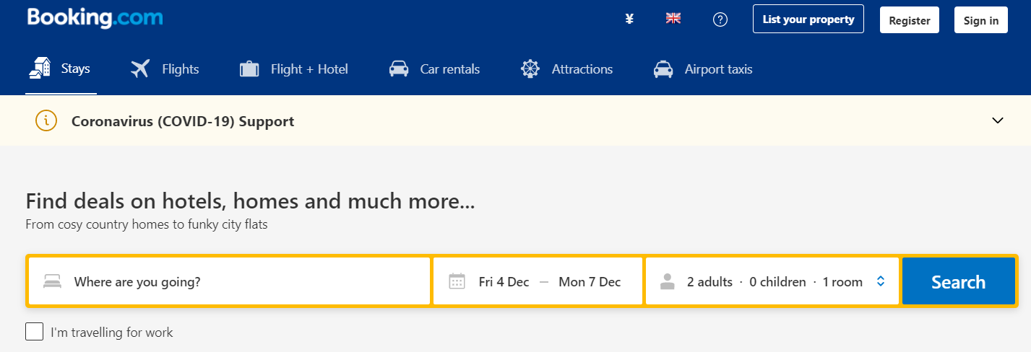In this part, I will use booking.com as an example：

Booking website collects and integrates complex tourist information through many computer technologies such as database, geographic information system and modern network technology, and conducts systematic management on it. It is a highly comprehensive and practical information management system.

Tourism information data such as maps, text, pictures, charts, video images, sounds, animations and remote sensing images of hotels and restaurants, tourist areas and scenic spots are provided by booking, and these data are respectively incorporated into the database of the system.

Booking collects the data according to its characteristics. The system categorizes, stores, edits, queries and retrieves the data, and then establishes the correlation between the data.

Booking system has two maintenance including system security maintenance and performance maintenance. Security maintenance is mainly to prevent illegal users from entering some modules through users permissions settings, and to prevent low-level users from using the system's top-secret data by authorizing different levels of users. Performance maintenance includes database updates, data backups, and system application modifications. You can then see "Find hotels, homes and more deals" on the site, and in the following search buttons , you can select your travel order by clicking on "Where are you going," "Date" and "Travel with a few people."

Customer ordering process: According to the buttons on the booking page, customers select the appropriate destination order through destination query, traffic information query, travel agency query, price query, date query, booking query, etc. After that background processing generate orders basis of information selected by customers. And it can make reasonable arrangements for the number of people, time, specific scenic spots, meals, guest rooms, tour guides, round-trip transportation and so on.

Booking’s advantages analysis:

Advantages of network promotion. Nowadays ,the advertisement about Booking can be seen in almost everywhere which shows its efforts in promoting in the Internet. In its home page ,customers will know the resources of tourist attractions and some details. To the computer users of Internet, they can use certain retrieval to find these information. According to the NDP's Online Research Center, there are almost 70 percent of online readers visit Booking system. What is more, the leisure travel sales are expected to reach $10 billion this year and grow to $35 billion in next year. while the internet travel sales are expected to grow about tenfold over in the next five years (Huang Shaohua, 2003). Therefore, the popularity of network promotion brings more business to the Booking.

Advantages of network reservation service. Booking using the most advanced and fast communication tool - the Internet transfer email to work with major travel agencies, airlines, hotels and they provide prices and details directly. Compared with the traditional method of door-to-door ticket purchase, booking can know whether the number of people is fully booked or not based on its close communication with the merchant through this way of email. In that way ,customers are able to compare different prices among the merchants to find out best one before they traveling. Meanwhile, the system can even display tourists virtual environment which shows layout of the room with specific location of the hotel. This not only reduces the intermediate links, but also saves time and money of tourists . Through the analysis of booking situation, staffs will get insight of the market’s demand and changing trends , which improves efficiency by saving manpower, and enables the management work to accurate. In a word ,using this network reservation service ,travelers would have convenient and safe experience.

The advantages of electronic payment. The Booking chose the most popular payment method as its default setting. Comparing with the traditional payment such as crash in some travel agency ,this new way brings a lot of convenience for people just need to bundle credit cards or travel cards online to pay for their bills in any time.

Advantages of feedback information. Booking receives feedback and suggestions from users, and at the same time statistics about travel products purchased through online Booking will generate relevant information such as tourists' interest in travel, consumption class, travel time and so on.

The popularity of tourism e-commerce. We all know more and more people choose this way to plan their travel. Not only it breaks limitations of time and space but also collects all data to analyse customers’ interest.

Usage of Big Data analytics. Booking makes decision management through receiving module feedback information and tourism service data, such as the number of tourists, expectations, suggestions, room occupancy rate, catering industry and tourism commodity sales data. For example,the system will automatically jump out the recommendations based on your browsing history.In that way,customers have more choices which may meet their needs well and save their time to compare them.Meanwhile,the Big Data analytice increases users’ browsing time by giving out their target goods to attract them.Therefore,there are more chances to promote sales.

**Business process flow diagram**

Customers:

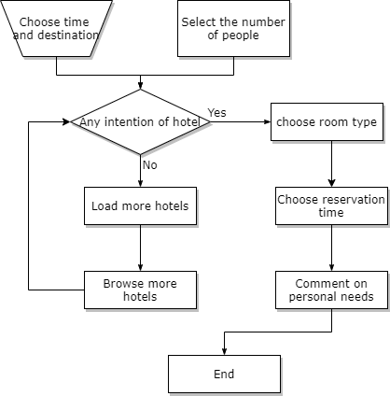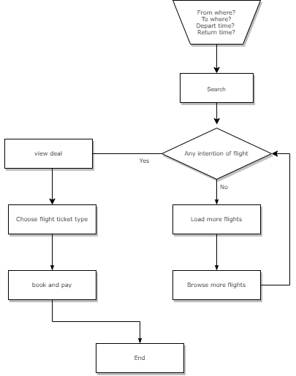In order to book a flight, lots of procedure are supposed to do by customers. To start with, customers are supposed to choose their current location, depart time and return time. After getting into all these input, the information system of booking.com will search the suitable flights in their database and display certain information fit for customers’ need. If the price of flight is within the ideal range of the customer, then he or she will choose flight ticket type. Otherwise, they will choose to browse more flights. Finally, after all these operations, the customers are bound to book and pay for their flights.

When it comes to reserve a room, the procedure is nearly the same. People can choose their time and destination and select the number of people according to their personal need. And if they have any intention to the customer need. They can choose a room type and make a reservation. Last but not least, they can make a comment to the hotel if they wish.

Merchants:

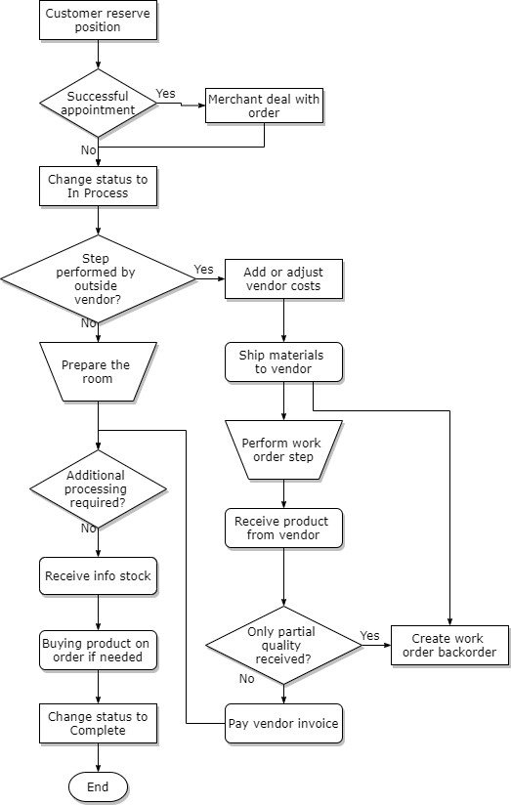

For merchants, the

**Features and functions**

The functions and features plays a key role in helping companies make better and more informed decisions. Instead of merely includes computers, an information system is an combination of people, data and technology.

The information system is made of five features, which are people and procedures, databases, software, hardware, telecommunications.

People are the most important part of an information system and procedures are guidelines or rules that help people to use software, hardware and data procedures. In the mode of operation of this website, customers, businesses and website staffs are all the people mentioned above, different people follow different rules to make this business model work.

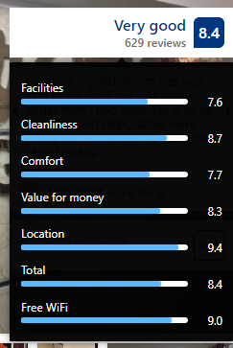 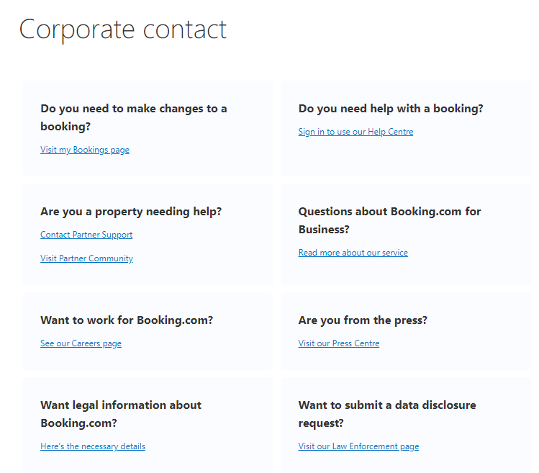

Database and telecommunications are also necessary. All customers and business information such as emails, names, preference destinations are stored in the database and exchanged in various machines through the network. Because of this, the website can provide customers with more suitable services in future.

Information systems have lots of functions, such as collecting input data, processing, storing and generating output information. Based on the website Booking.com, key functions of the information system will be analyzed below.

Input is the process of entering data into the computer system. On the homepage of Booking.com, customers can type in itinerary to book suitable hotel rooms, air tickets, airport shuttle bus, car rental and attraction tickets.

QQ图片20201205163757

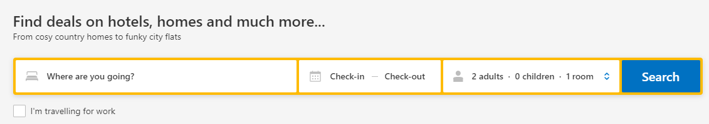

In terms of accommodation, after selecting the destination city, customers can choose their own accommodation time and filter specific hotels according to conditions.

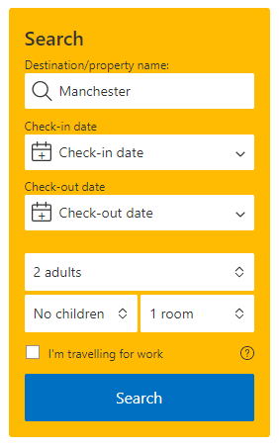 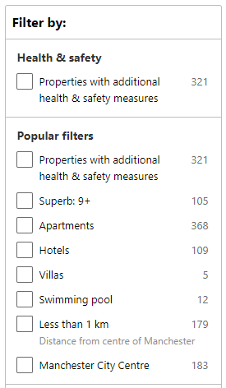

Processing is the process of converting input data into output information. Through this process, the data that people enter is transformed into the result they need. Then, the screen will output the information users need.

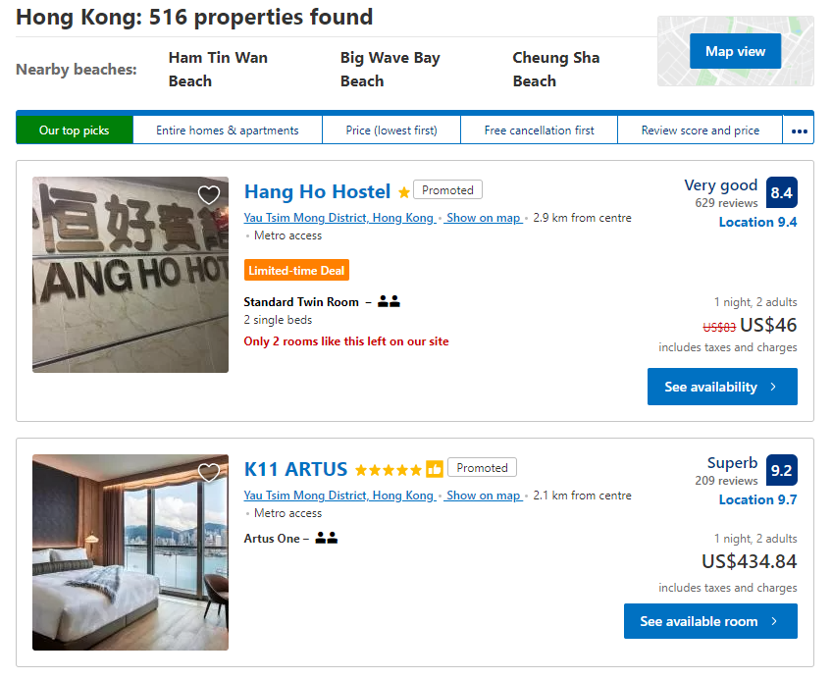

**Information and technology used in the system**

Here are some descriptions of the information and technologies used in the booking system.

Input

In the web page, there are three dialogs that can be input.You can enter "where are you going" in the first one, which is to enter your destination. The second one is to select your check in and check out time. For the third one, you can choose the number of adults and children, as well as the number of rooms you need. Click the “search” button, you have completed the input process. Of course, you can change your selection at any time in the dialog box on the left side of the page.

Output

The web page will skip to the output interface when you click the icon. The website will give different screening criteria such as price, star rating and so on according to your previous choice. After further screening, the website will list out the hotels from high to low or in reverse order. This is the output of booking.com.

Feedback

In the output page, you can also see the feedback from the customers, such as "wonderful" and "excellent".What is more, there are an evaluation criterion for customers to mark the hotels and services.They give the suggestions and advises to them,and Booking.com website collect this information and give back to the merchants to improve goods quality.

Technical components

After the account of the feedback , the following is some information about the technical components. Booking.com using MySQL as the main database solution and it is one of the largest MySQL users with a lot of services and groups in Europe currently.Using this database, Booking.com system can achieve remote disaster-tolerant easily. Here are some descriptions of the website's database architecture.

A MySQL is generally divided into three layers. The first layer is the Master, and the lower layer is IM (Intermediate Master) with different slave servers. And why people choose this way to divide it? First of all, in order to meet the requirements of remote disaster-tolerant which needs some databases in different areas to prevent data loss, the data center must have a complete set of replication links with at least two IM to ensure the continuous and stable operation of the program. Another reason is the limitation of network bandwidth that if too many slave servers are attached to an IM, all network bandwidth will be directly used up. In that way, the usage of many IM with similar hardware at the same time will work out this problem and every IM can become master server if the master server has problems.

In addition, an officer worked in Booking.com made open sources software called Orchestrator for this information system which can meet the needs of the website.

Orchestrator is a tool for topology management and visualization of MySQL replication. When a new MySQL node is added or deleted, it will automatically update the topology, and you can change the level of MySQL in the data link at any time. It provides the interface operation of web page, and can also be operated through the command line. It is able to detect the downtime of MySQL and recover it automatically.

**Security and ethical issues**

Neither the mobile app nor the web page automatically obtains the user's GPS location information, but allows the user to input it by themselves or determine the user's destination through a large number of recommended locations on the homepage. So as to avoid leakage of users detailed location data.

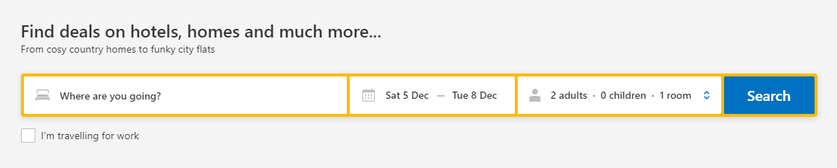

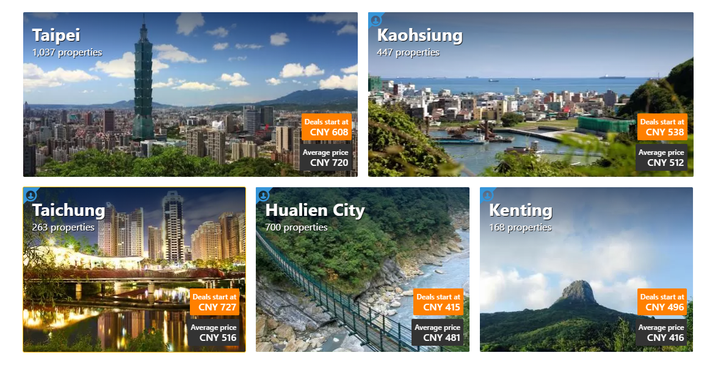In the process of booking a hotel in this website, booking.com will ask the user for their name, preferred contact details, the names of the people travelling with you and your payment information. All personal information designed in this link will be sent to the Booking.com.com B.V. data processing center in the Netherlands. Booking.com.com only discloses data following a data disclosure request which is legally binding to Booking.com.com B.V. under Dutch laws. Exceptions are made for emergency situations.

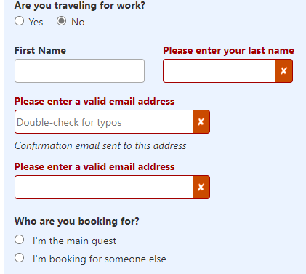

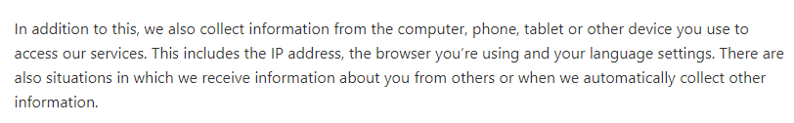Although booking.com will not obtain the user's exact location information through GPS, it will collect relevant information from computers, phones, tablets or other devices you use to obtain booking.com services. This also includes the IP address , the browsers you use and the setting of language. We sometimes collect information about you from other people or collect other information automatically. Although booking.com stated that the acquisition of these personal data is used to help customers to manage online travel orders and ensure that users can obtain ideal services, it cannot guarantee that such data will not be leaked.And if this information is leaked, hackers can easily determine your location through the IP address, which may threaten the safety of life.For example,almost everyone have got telephone harassment and this is the result of leaking private information

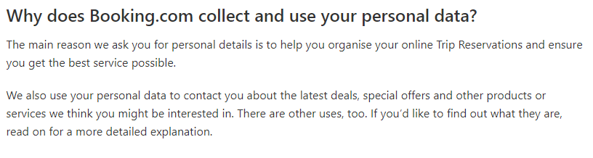

(confidentiality agreement in Booking.com)

Booking.com has a relatively complete information protection system, which can effectively prevent intrusion and reduce the risk of user data leakage

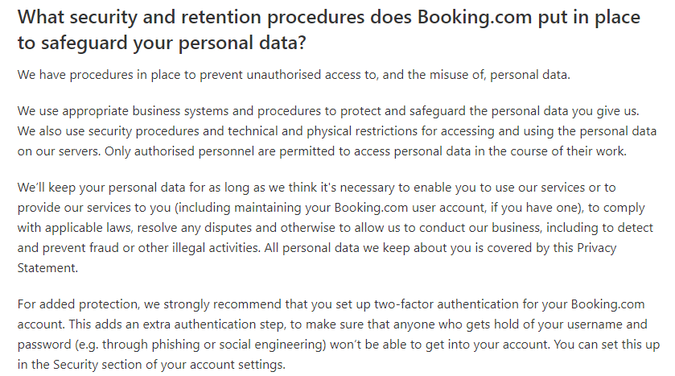(confidentiality agreement in Booking.com)

# References

*Booking_Holdings*. (2020, 9 25). Retrieved from Wikipedia: https://zh.wikipedia.org/wiki/

features-and-functions-of-information-systems. (2020). Retrieved from: https://www.answerkid.co.uk/features-and-functions-of-information-systems/

Huang ShaohuaRentaoHUANG. (2003). Tourism Information System Analysis and Design based on WebGIS.

Mr.Jian. (2020, 7 3). Retrieved from The development of Booking Holdings: https://baijiahao.baidu.com

